InternSpark INTERNSHIP TASK DOCUMENTATION
TASK - 1
IMPLEMENTATION OF CORE DATA STRUCTURES FROM SCRATCH
Data Structures Implemented:-
Linked List | Stack | Queue | Binary Search Tree
Programming Language: C++
Development Environment: Visual Studio Code
Compiler: GNU g++
Version Control: Git & GitHub
Submitted by:
Nivedita Sikarwar

TABLE OF CONTENTS
- Project Overview
- Objectives
- Development Environment
- Linked List
- Stack
- Queue
- Binary Search Tree
- Compilation and Execution
- Testing and Validation
- Conclusion

PROJECT OVERVIEW
This project focuses on the implementation of fundamental data structures from scratch using C++. The purpose of the project is to develop a practical understanding of how data structures store, organize, access, and manipulate data.
The following data structures have been implemented:
- Linked List
- Stack
- Queue
- Binary Search Tree
Each data structure is implemented as an independent C++ program with a menu-driven interface. The programs allow users to perform the fundamental operations associated with each data structure.
The implementation focuses on understanding the internal working of data structures rather than relying on built in data structure libraries.
OBJECTIVES
The major objectives of this project are:
- To understand the fundamental concepts of data structures.
- To implement core data structures from scratch using C++.
- To understand the use of pointers and dynamic memory allocation.
- To implement insertion, deletion, searching, and traversal operations.
- To understand the LIFO principle used by stacks.
- To understand the FIFO principle used by queues.
- To implement searching and traversal operations in a Binary Search Tree.
- To analyze the time and space complexity of different operations.
- To develop menu-driven and user-interactive programs.
- To gain practical experience in compiling, executing, and testing C++ programs.

DEVELOPMENT ENVIRONMENT
Component | Specification
Programming Language | C++
Compiler | GNU g++
IDE | Visual Studio Code
Version Control | Git / GitHub
Operating System | Windows
Build Method | Direct g++ compilation

Environment Verification
The GNU C++ compiler was verified using the following command:
g++ --version
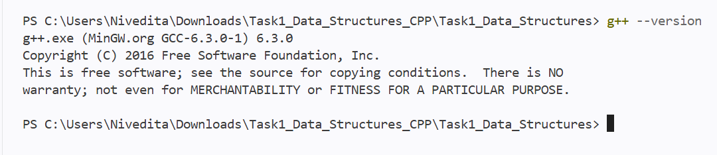
Figure 1: Verification of the GNU g++ Compiler
LINKED LIST
LINKED LIST IMPLEMENTATION
1. Project Overview
This module implements a Singly Linked List from scratch using C++.
The implementation uses dynamically allocated nodes connected through pointers. Each node stores an integer value and a pointer to the next node.
The program provides a menu-driven interface through which the user can:
- Insert an element
- Delete an element
- Search for an element
- Display the complete list
- Exit the program
The implementation focuses on understanding pointer-based data structures, dynamic memory allocation, node traversal, and basic linked list operations.

2. Objectives
The main objectives of this implementation are:
- Implement a singly linked list using C++.
- Create and manage nodes dynamically.
- Perform insertion at the end of the list.
- Delete the first occurrence of a specified value.
- Search for an element using traversal.
- Display all elements of the list.
- Handle an empty linked list.
- Release dynamically allocated memory using a destructor.

3. Technology and Environment
Parameter | Details
Language | C++
Compiler | GNU G++
Programming Concept | Object-Oriented Programming
Data Structure | Singly Linked List
Memory Management | Dynamic Allocation
Interface | Command-Line / Menu Driven

4. Implementation Details
4.1 Node Structure
The linked list is built using a Node structure.
Each node contains:
struct Node {
int data;
Node* next;
};
Components
data
Stores the integer value of the node.
next
Stores the address of the next node.
The constructor initializes the node with the given value and sets next to nullptr.
Conceptually, the structure of the list is:
+------+------+
| Data | Next | -----> Next Node
+------+------+
The next pointer of the last node contains NULL.

4.2 Linked List Representation
The LinkedList class maintains a pointer named head.
Node* head;
head points to the first node of the list.
When the list contains no elements:
head
↓
NULL
For example, after inserting 10, 20, and 30:
head
↓
+----+------+ +----+------+ +----+------+
| 10 | ●------>| 20 | ●------>| 30 | NULL |
+----+------+ +----+------+ +----+------+

5. Operations Implemented
5.1 Insert
Function
void insert(int value)
The insert() function adds a new node at the end of the linked list.
Working
- Create a new node dynamically.
- If the list is empty, make the new node the head.
- Otherwise, traverse the list until the last node.
- Connect the last node to the newly created node.
Example
Before insertion:
10 -> 20 -> NULL
Insert 30:
10 -> 20 -> 30 -> NULL
Complexity
Time: O(n)
Space: O(1) auxiliary space
Since the implementation does not maintain a tail pointer, the list must be traversed to reach the last node.

5.2 Delete
Function
bool remove(int value)
The remove() function deletes the first node containing the specified value.
Working
- If the list is empty, deletion fails.
- If the first node contains the value, head is moved to the next node.
- Otherwise, the list is traversed to locate the required node.
- The previous node is linked directly to the next node.
- The removed node is deallocated using delete.
Example
Before deletion:
10 -> 20 -> 30 -> NULL
Delete 20:
10 -> 30 -> NULL
If the value does not exist:
Value not found.
Complexity
Time: O(n)
Space: O(1) auxiliary space

5.3 Search
Function
bool search(int value)
The search() function checks whether a given value exists in the linked list.
Working
- Start traversal from head.
- Compare each node's data with the target value.
- Continue until the value is found or the end of the list is reached.
- Return the appropriate result.
Output
If the value exists:
Value found.
If the value does not exist:
Value not found.
Complexity
Time: O(n)
Space: O(1) auxiliary space

5.4 Display
Function
void display()
The display() function traverses the complete linked list and prints each node's value.
For example:
Linked List: 10 -> 20 -> 30 -> NULL
If no nodes are present:
List is empty.
Complexity
Time: O(n)
Space: O(1) auxiliary space

5.5 Destructor
Function
~LinkedList()
Since nodes are created dynamically using new, the destructor is used to release the allocated memory.
It traverses the linked list and deletes each node before the LinkedList object is destroyed.
This ensures that dynamically allocated memory is properly released.
Complexity
Time: O(n)

6. Program Interface
The program uses a menu-driven command-line interface:
--- Linked List ---
1. Insert
2. Delete
3. Search
4. Display
5. Exit
The program repeatedly accepts the user's choice until option 5 is selected.

7. Sample Execution
The following execution demonstrates insertion, display, search, deletion, and exit operations.
--- Linked List ---
1. Insert
2. Delete
3. Search
4. Display
5. Exit
Enter choice: 1
Enter value: 10
Value inserted.

--- Linked List ---
1. Insert
2. Delete
3. Search
4. Display
5. Exit
Enter choice: 1
Enter value: 20
Value inserted.

--- Linked List ---
1. Insert
2. Delete
3. Search
4. Display
5. Exit
Enter choice: 1
Enter value: 30
Value inserted.

--- Linked List ---
1. Insert
2. Delete
3. Search
4. Display
5. Exit
Enter choice: 4
Linked List: 10 -> 20 -> 30 -> NULL

--- Linked List ---
1. Insert
2. Delete
3. Search
4. Display
5. Exit
Enter choice: 3
Enter value to search: 20
Value found.

--- Linked List ---
1. Insert
2. Delete
3. Search
4. Display
5. Exit
Enter choice: 2
Enter value to delete: 20
Value deleted.

--- Linked List ---
1. Insert
2. Delete
3. Search
4. Display
5. Exit
Enter choice: 4
Linked List: 10 -> 30 -> NULL

--- Linked List ---
1. Insert
2. Delete
3. Search
4. Display
5. Exit
Enter choice: 5
Exiting...

8. Complexity Analysis
Operation | Time Complexity | Auxiliary Space
Insert | O(n) | O(1)
Delete | O(n) | O(1)
Search | O(n) | O(1)
Display | O(n) | O(1)

Overall Space Complexity
The linked list requires O(n) memory for storing n nodes.
The additional working space used by individual operations is O(1), excluding the memory occupied by the nodes themselves.

9. Validation and Test Cases
The implementation was tested using different input scenarios to verify the correctness of each operation.
Test Case | Input / Operation | Expected Result
1 | Insert 10, 20, 30 | Elements inserted successfully
2 | Display | 10 -> 20 -> 30 -> NULL
3 | Search 20 | Value found.
4 | Delete 20 | Value deleted.
5 | Display | 10 -> 30 -> NULL
6 | Search unavailable value | Value not found.
7 | Display empty list | List is empty.

10. Screenshots
Program Execution:-
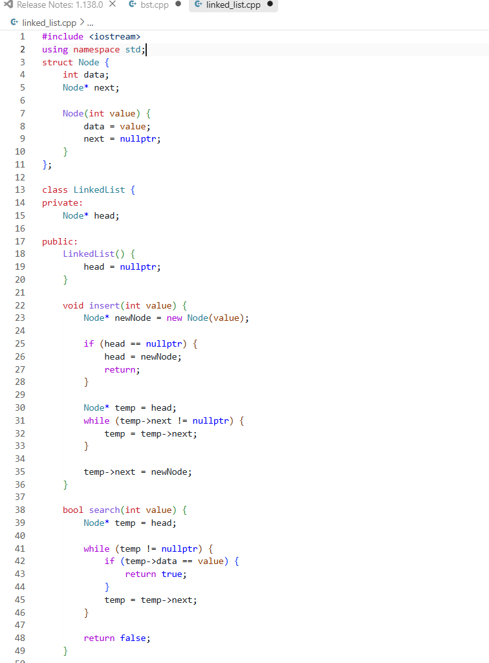
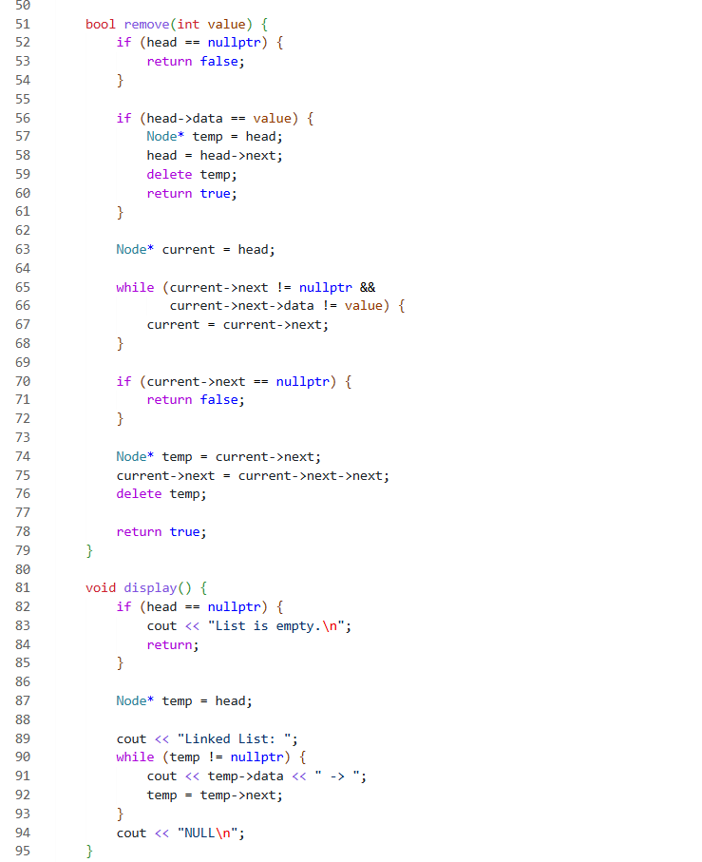
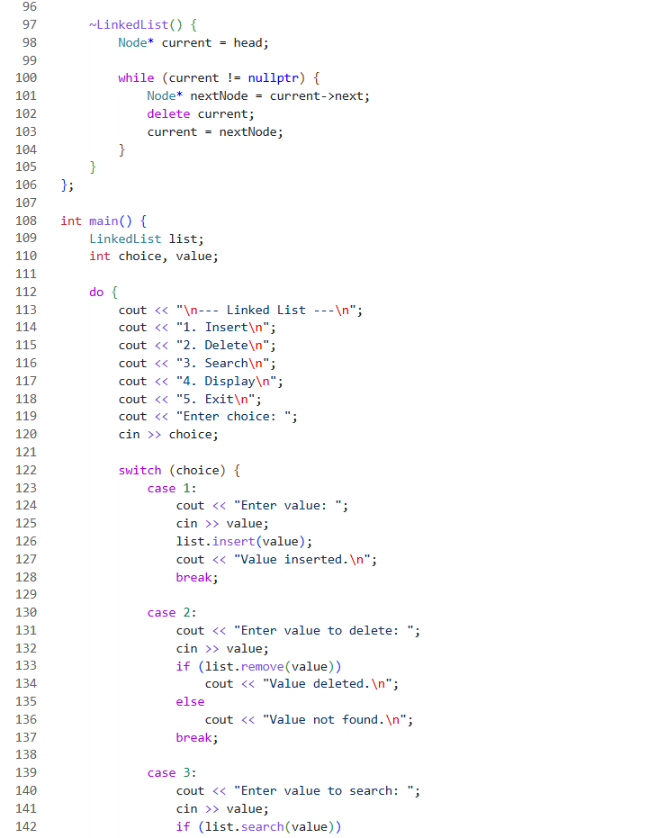
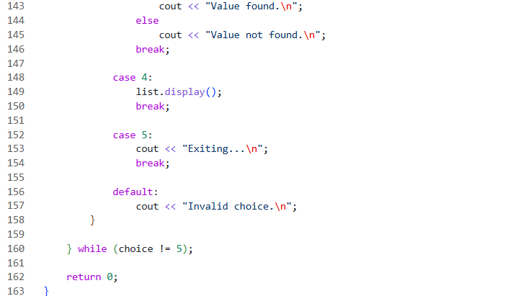
Final Output
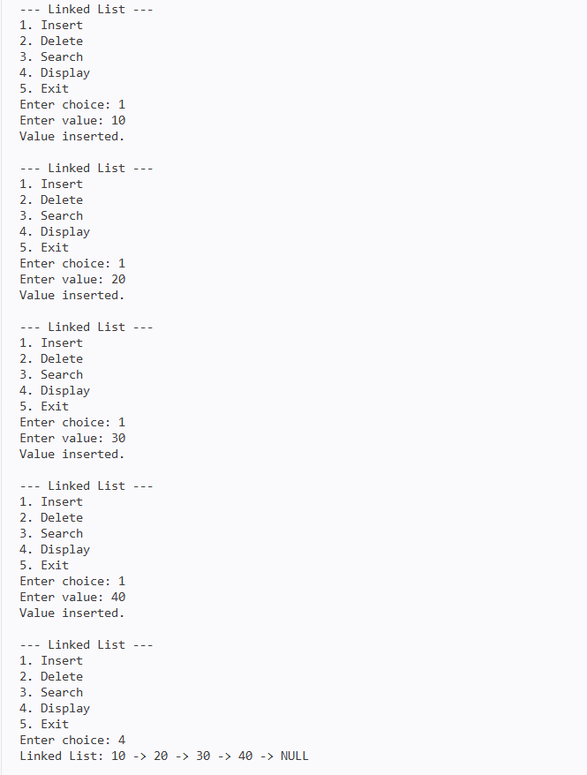
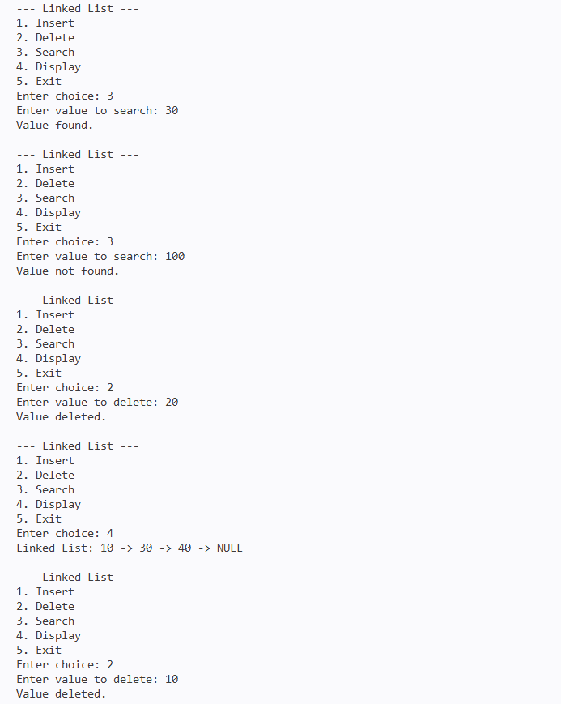
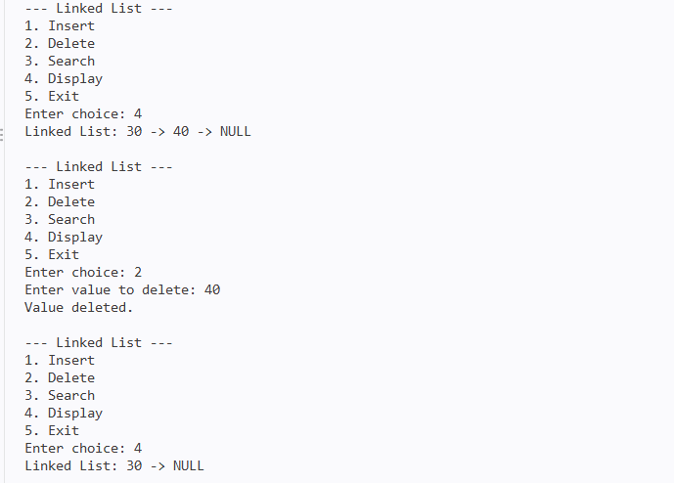

11. Result
The singly linked list was successfully implemented from scratch in C++.
The implementation correctly supports:
- Insertion at the end
- Deletion of the first matching node
- Linear search
- List traversal and display
- Empty-list handling
- Dynamic memory allocation and deallocation
The program was compiled and tested successfully using GNU G++.

12. Conclusion
This implementation provides a practical understanding of how a singly linked list is created and managed using pointers and dynamic memory allocation in C++.
Through the implementation of insertion, deletion, searching, and traversal, the project demonstrates the fundamental operations of a pointer-based linear data structure. The use of a destructor also ensures proper memory management when dynamically allocated nodes are no longer required.

STACK
STACK IMPLEMENTATION
1. Project Overview
This module implements a Stack data structure from scratch using C++.
The stack is implemented using a fixed-size array with a maximum capacity of 100 elements. The implementation follows the LIFO (Last In, First Out) principle, where the element inserted last is removed first.
The program provides a menu-driven interface with the following operations:
- Push
- Pop
- Peek
- Search
- Display
- Exit
The implementation demonstrates the fundamental concepts of stack operations, array-based storage, boundary conditions, and LIFO-based data access.

2. Objectives
The main objectives of this implementation are:
- Implement a stack using an array.
- Understand the LIFO principle.
- Perform push and pop operations.
- Access the top element using peek.
- Search for an element in the stack.
- Display elements from top to bottom.
- Handle stack overflow and underflow conditions.
- Manage the stack using a top index.

3. Technology and Environment
Parameter | Details
Language | C++
Compiler | GNU G++
Programming Concept | Classes and Objects
Data Structure | Stack
Implementation | Array-based
Maximum Capacity | 100 elements
Interface | Command-Line / Menu Driven

4. Implementation Details
4.1 Stack Representation
The stack is implemented using a fixed-size integer array:
int arr[MAX_SIZE];
The maximum stack size is defined as:
static const int MAX_SIZE = 100;
Therefore, the stack can store a maximum of 100 integer elements.
A variable named top is used to track the index of the current top element.
int top;
Initially:
top = -1;
This indicates that the stack is empty.
Stack Representation
For example, after pushing 10, 20, and 30:
TOP
↓
+----+
| 30 |
+----+
| 20 |
+----+
| 10 |
+----+
The value 30 is the top element and will be removed first.

5. Stack Operations
5.1 Push
Function
void push(int value)
The push() operation adds a new element to the top of the stack.
Working
- Check whether the stack is full.
- If the stack is full, display Stack Overflow.
- Otherwise, increment top.
- Store the new value at arr[top].
- Display a confirmation message.
Example
Before push:
20
10
Push 30:
30 ← TOP
20
10
Output
Value pushed.
Complexity
Time: O(1)
Auxiliary Space: O(1)

5.2 Pop
Function
void pop()
The pop() operation removes the element currently present at the top of the stack.
Working
- Check whether the stack is empty.
- If empty, display Stack Underflow.
- Otherwise, display the top element.
- Decrement top.
Example
Before pop:
30 ← TOP
20
10
After pop:
20 ← TOP
10
Output
Removed: 30
Complexity
Time: O(1)
Auxiliary Space: O(1)

5.3 Peek
Function
void peek()
The peek() operation displays the current top element without removing it.
Working
- If the stack is empty, display Stack is empty.
- Otherwise, access arr[top] and display its value.
Example
For:
30 ← TOP
20
10
The output is:
Top element: 30
The stack remains unchanged.
Complexity
Time: O(1)
Auxiliary Space: O(1)

5.4 Search
Function
void search(int value)
The search() operation checks whether a specified value exists in the stack.
The search starts from the top of the stack and moves towards the bottom.
Working
- Start from index top.
- Compare each element with the given value.
- Continue towards index 0.
- If the value is found, display its stack position.
- If the value is not found, display Value not found.
The stack position is calculated as:
i + 1
Therefore, the bottom-most element has position 1.
Example
30 ← Position 3
20 ← Position 2
10 ← Position 1
Searching for 20 produces:
Value found at stack position 2.
Complexity
Time: O(n)
Auxiliary Space: O(1)

5.5 Display
Function
void display()
The display() operation prints all elements of the stack starting from the top and moving towards the bottom.
Example
For a stack containing:
30
20
10
The output is:
Stack (top to bottom): 30 20 10
If the stack is empty:
Stack is empty.
Complexity
Time: O(n)
Auxiliary Space: O(1)

6. Boundary Conditions
The implementation explicitly handles two important stack conditions.
Stack Overflow
Stack overflow occurs when an attempt is made to push an element into a full stack.
The program displays:
Stack Overflow.
The maximum capacity of the stack is 100 elements.

Stack Underflow
Stack underflow occurs when an attempt is made to pop an element from an empty stack.
The program displays:
Stack Underflow.

7. Helper Functions
The implementation uses two helper functions to check the current state of the stack.
isEmpty()
bool isEmpty()
Returns true when:
top == -1
Otherwise, it returns false.
isFull()
bool isFull()
Returns true when:
top == MAX_SIZE - 1
This indicates that the stack has reached its maximum capacity.

8. Program Interface
The program uses a menu-driven command-line interface:
--- Stack ---
1. Push
2. Pop
3. Peek
4. Search
5. Display
6. Exit
Enter choice:
The menu is displayed repeatedly until the user selects option 6.

9. Sample Execution
The following execution demonstrates push, display, peek, search, pop, and exit operations.
--- Stack ---
1. Push
2. Pop
3. Peek
4. Search
5. Display
6. Exit
Enter choice: 1
Enter value: 10
Value pushed.

--- Stack ---
1. Push
2. Pop
3. Peek
4. Search
5. Display
6. Exit
Enter choice: 1
Enter value: 20
Value pushed.

--- Stack ---
1. Push
2. Pop
3. Peek
4. Search
5. Display
6. Exit
Enter choice: 1
Enter value: 30
Value pushed.

--- Stack ---
1. Push
2. Pop
3. Peek
4. Search
5. Display
6. Exit
Enter choice: 5
Stack (top to bottom): 30 20 10

--- Stack ---
1. Push
2. Pop
3. Peek
4. Search
5. Display
6. Exit
Enter choice: 3
Top element: 30

--- Stack ---
1. Push
2. Pop
3. Peek
4. Search
5. Display
6. Exit
Enter choice: 4
Enter value to search: 20
Value found at stack position 2.

--- Stack ---
1. Push
2. Pop
3. Peek
4. Search
5. Display
6. Exit
Enter choice: 2
Removed: 30

--- Stack ---
1. Push
2. Pop
3. Peek
4. Search
5. Display
6. Exit
Enter choice: 5
Stack (top to bottom): 20 10

--- Stack ---
1. Push
2. Pop
3. Peek
4. Search
5. Display
6. Exit
Enter choice: 6
Exiting...

10. Complexity Analysis
Operation | Time Complexity | Auxiliary Space
Push | O(1) | O(1)
Pop | O(1) | O(1)
Peek | O(1) | O(1)
Search | O(n) | O(1)
Display | O(n) | O(1)
isEmpty | O(1) | O(1)
isFull | O(1) | O(1)

Overall Space Complexity
The stack uses a fixed-size array of 100 integers.
Therefore, the allocated storage for the stack array is O(100), which is effectively O(1) with respect to the number of elements currently stored.

11. Validation and Test Cases
The implementation was tested using different operations and boundary conditions.
Test Case | Operation | Expected Result
1 | Push 10, 20, 30 | Values pushed successfully
2 | Display | 30 20 10
3 | Peek | Top element: 30
4 | Search 20 | Value found at stack position 2.
5 | Pop | Removed: 30
6 | Display | 20 10
7 | Search unavailable value | Value not found.
8 | Pop from empty stack | Stack Underflow.
9 | Push into full stack | Stack Overflow.

12. Screenshots
Program Execution:-
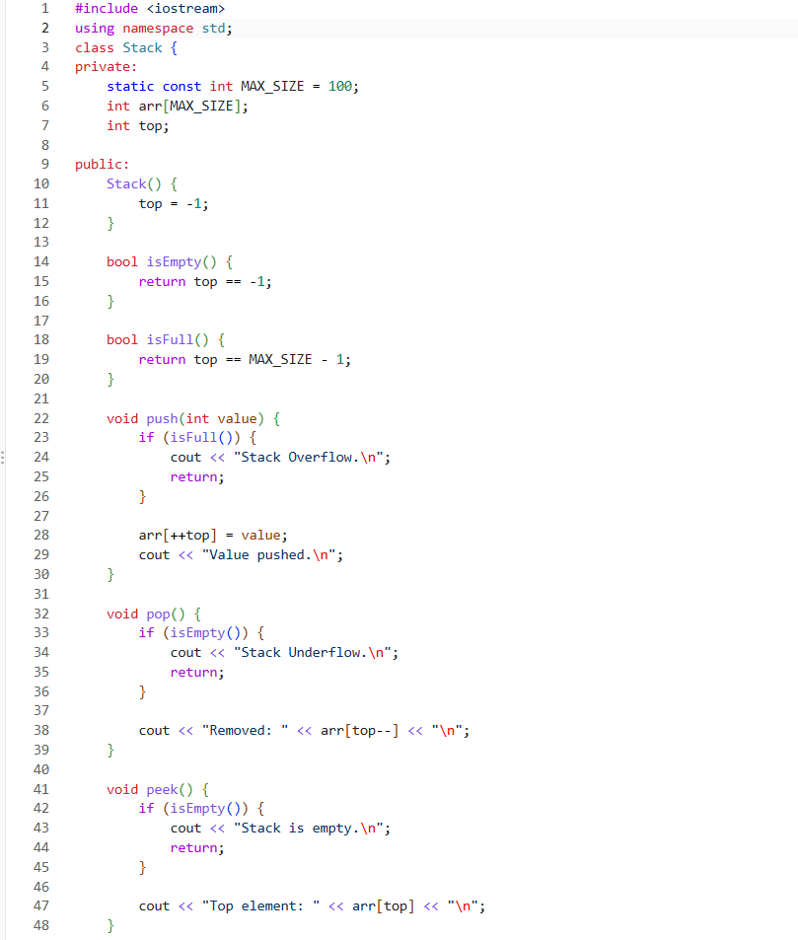

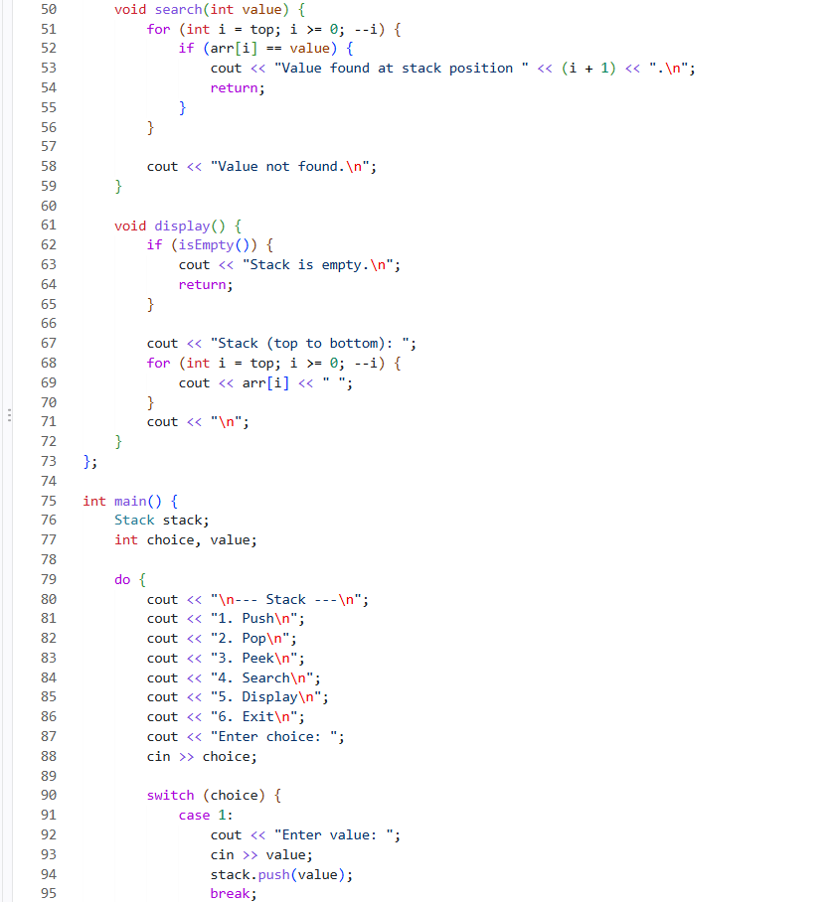
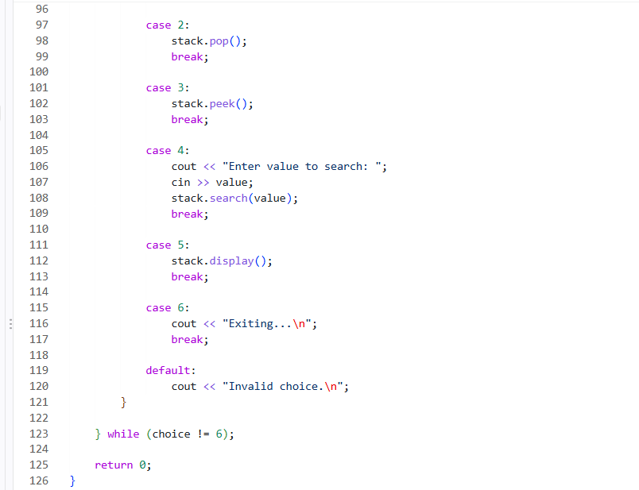
Operations and Output:-
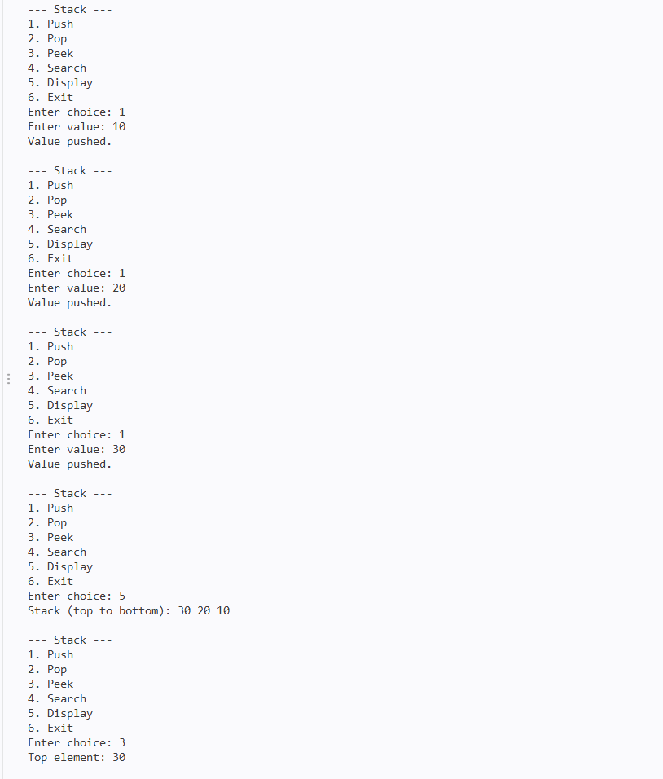
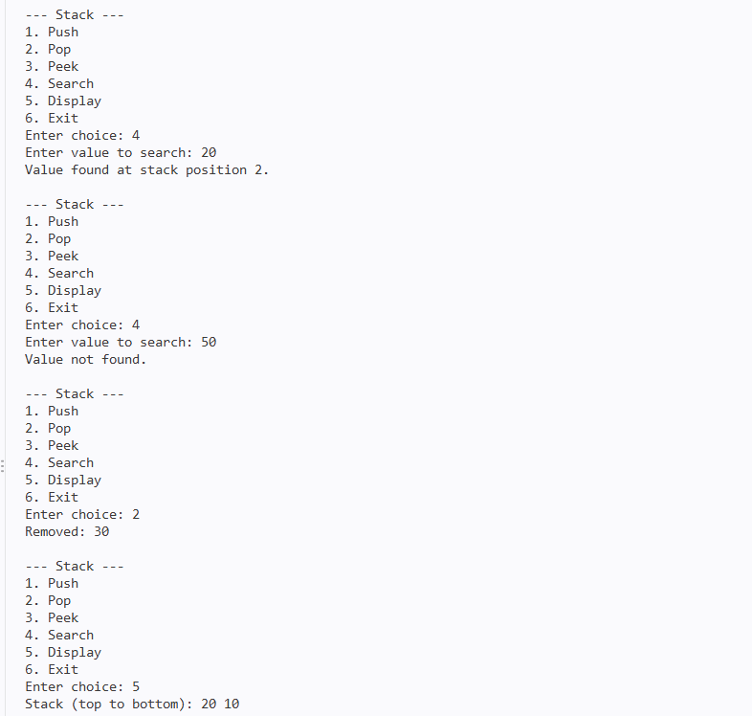
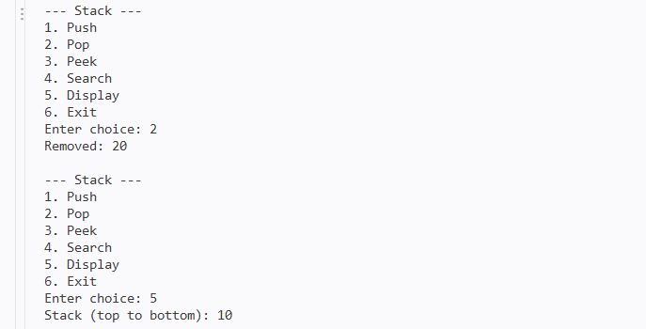

13. Result
The stack was successfully implemented using a fixed-size array in C++.
The program correctly performs:
- Push operation
- Pop operation
- Peek operation
- Search operation
- Display operation
- Overflow detection
- Underflow detection
- Empty and full stack checks
The implementation follows the LIFO (Last In, First Out) principle and was successfully compiled and tested using GNU G++.

14. Conclusion
This implementation demonstrates the fundamental working of a stack using an array-based approach in C++. It provides practical understanding of the LIFO principle, top-index management, insertion and deletion from the top, element searching, and boundary-condition handling.
The implementation also demonstrates how stack overflow and underflow conditions can be detected and handled effectively in a menu-driven program.
QUEUE IMPLEMENTATION
1. Project Overview
This module implements a Queue data structure from scratch using C++.
The queue is implemented using a fixed-size circular array with a maximum capacity of 100 elements. It follows the FIFO (First In, First Out) principle, where the element inserted first is removed first.
The circular implementation allows the queue to reuse the array positions that become available after dequeue operations.
The program provides a menu-driven interface with the following operations:
- Enqueue
- Dequeue
- Front
- Search
- Display
- Exit

2. Objectives
The main objectives of this implementation are:
- Implement a queue using an array.
- Understand the FIFO principle.
- Implement a circular queue using modulo arithmetic.
- Perform enqueue and dequeue operations.
- Access the front element without removing it.
- Search for an element in the queue.
- Display elements from front to rear.
- Handle queue overflow and underflow conditions.

3. Technology and Environment
Parameter | Details
Language | C++
Compiler | GNU G++
Programming Concept | Classes and Objects
Data Structure | Queue
Implementation | Circular Array
Maximum Capacity | 100 elements
Interface | Command-Line / Menu Driven

4. Implementation Details
4.1 Queue Representation
The queue is implemented using a fixed-size integer array:
int arr[MAX_SIZE];
The maximum capacity is defined as:
static const int MAX_SIZE = 100;
Therefore, the queue can store a maximum of 100 elements at a time.
The implementation uses three variables to manage the queue:
int frontIndex;
int rearIndex;
int count;
frontIndex
Stores the index of the element currently at the front of the queue.
rearIndex
Stores the index where the most recently inserted element is located.
count
Stores the current number of elements present in the queue.

4.2 Initial State
When a new queue object is created, the constructor initializes:
frontIndex = 0;
rearIndex = -1;
count = 0;
This represents an empty queue.
Conceptually:
Front
↓
[ ][ ][ ][ ][ ]
↑
Rear
No elements are present initially.

5. Circular Queue Implementation
The queue uses circular indexing to reuse available array positions.
Whenever an element is inserted or removed, the index is updated using:
(index + 1) % MAX_SIZE
For example, after reaching the last array position, the next position becomes the first position again.
0 → 1 → 2 → 3 → ... → 98 → 99
↑ ↓
└─────────────────────────┘
This prevents unused positions at the beginning of the array from being wasted after dequeue operations.

6. Queue Operations
6.1 Enqueue
Function
void enqueue(int value)
The enqueue() operation inserts a new element at the rear of the queue.
Working
- Check whether the queue is full.
- If full, display Queue Overflow.
- Update rearIndex using circular indexing.
- Store the new value at the updated rear position.
- Increase count.
- Display a confirmation message.
The rear index is updated using:
rearIndex = (rearIndex + 1) % MAX_SIZE;
Example
Before insertion:
Front → 10 20 30 ← Rear
Enqueue 40:
Front → 10 20 30 40 ← Rear
Output
Value inserted into queue.
Complexity
Time: O(1)
Auxiliary Space: O(1)

6.2 Dequeue
Function
void dequeue()
The dequeue() operation removes the element from the front of the queue.
Working
- Check whether the queue is empty.
- If empty, display Queue Underflow.
- Display the front element.
- Move frontIndex to the next position using circular indexing.
- Decrease count.
The front index is updated using:
frontIndex = (frontIndex + 1) % MAX_SIZE;
Example
Before deletion:
Front → 10 20 30 ← Rear
After dequeue:
Front → 20 30 ← Rear
Output
Removed: 10
Complexity
Time: O(1)
Auxiliary Space: O(1)

6.3 Front
Function
void front()
The front() operation displays the element currently present at the front of the queue without removing it.
Working
- If the queue is empty, display Queue is empty.
- Otherwise, access arr[frontIndex].
Example
For:
Front → 10 20 30 ← Rear
The output is:
Front element: 10
The queue remains unchanged.
Complexity
Time: O(1)
Auxiliary Space: O(1)

6.4 Search
Function
void search(int value)
The search() operation checks whether a specified value exists in the queue.
The search starts from the front and checks each element up to the rear.
Working
- Check whether the queue is empty.
- Start traversal from frontIndex.
- Check exactly count elements.
- Calculate each position using circular indexing.
- If the value is found, display Value found in queue.
- Otherwise, display Value not found.
The index is calculated as:
int index = (frontIndex + i) % MAX_SIZE;
Output
If the value exists:
Value found in queue.
If the value does not exist:
Value not found.
Complexity
Time: O(n)
Auxiliary Space: O(1)

6.5 Display
Function
void display()
The display() operation prints all queue elements from front to rear.
Example
For:
Front → 10 20 30 ← Rear
The output is:
Queue (front to rear): 10 20 30
The display operation also uses circular indexing to correctly access elements when the queue wraps around the end of the array.
If the queue is empty:
Queue is empty.
Complexity
Time: O(n)
Auxiliary Space: O(1)

7. Queue Boundary Conditions
The implementation handles two important boundary conditions.
Queue Overflow
Queue overflow occurs when an attempt is made to insert an element into a full queue.
The program checks:
count == MAX_SIZE
and displays:
Queue Overflow.
The maximum capacity is 100 elements.

Queue Underflow
Queue underflow occurs when an attempt is made to remove an element from an empty queue.
The program checks:
count == 0
and displays:
Queue Underflow.

8. Helper Functions
The implementation uses two helper functions to determine the current state of the queue.
isEmpty()
bool isEmpty()
Returns true when:
count == 0
Otherwise, it returns false.

isFull()
bool isFull()
Returns true when:
count == MAX_SIZE
This indicates that all 100 queue positions are currently occupied.

9. Program Interface
The program uses a menu-driven command-line interface:
--- Queue ---
1. Enqueue
2. Dequeue
3. Front
4. Search
5. Display
6. Exit
Enter choice:
The menu continues to appear until the user selects option 6.

10. Sample Execution
The following execution demonstrates enqueue, display, front, search, dequeue, and exit operations.
--- Queue ---
1. Enqueue
2. Dequeue
3. Front
4. Search
5. Display
6. Exit
Enter choice: 1
Enter value: 10
Value inserted into queue.

--- Queue ---
1. Enqueue
2. Dequeue
3. Front
4. Search
5. Display
6. Exit
Enter choice: 1
Enter value: 20
Value inserted into queue.

--- Queue ---
1. Enqueue
2. Dequeue
3. Front
4. Search
5. Display
6. Exit
Enter choice: 1
Enter value: 30
Value inserted into queue.

--- Queue ---
1. Enqueue
2. Dequeue
3. Front
4. Search
5. Display
6. Exit
Enter choice: 5
Queue (front to rear): 10 20 30

--- Queue ---
1. Enqueue
2. Dequeue
3. Front
4. Search
5. Display
6. Exit
Enter choice: 3
Front element: 10

--- Queue ---
1. Enqueue
2. Dequeue
3. Front
4. Search
5. Display
6. Exit
Enter choice: 4
Enter value to search: 20
Value found in queue.

--- Queue ---
1. Enqueue
2. Dequeue
3. Front
4. Search
5. Display
6. Exit
Enter choice: 2
Removed: 10

--- Queue ---
1. Enqueue
2. Dequeue
3. Front
4. Search
5. Display
6. Exit
Enter choice: 5
Queue (front to rear): 20 30

--- Queue ---
1. Enqueue
2. Dequeue
3. Front
4. Search
5. Display
6. Exit
Enter choice: 6
Exiting...

11. Complexity Analysis
Operation | Time Complexity | Auxiliary Space
Enqueue | O(1) | O(1)
Dequeue | O(1) | O(1)
Front | O(1) | O(1)
Search | O(n) | O(1)
Display | O(n) | O(1)
isEmpty | O(1) | O(1)
isFull | O(1) | O(1)

Overall Space Complexity
The queue uses a fixed-size array of 100 integers.
Therefore, the allocated storage is O(100), which is effectively O(1) with respect to the number of elements currently stored.

12. Validation and Test Cases
The implementation was tested using normal operations as well as boundary conditions.
Test Case | Operation | Expected Result
1 | Enqueue 10, 20, 30 | Values inserted successfully
2 | Display | 10 20 30
3 | Front | Front element: 10
4 | Search 20 | Value found in queue.
5 | Dequeue | Removed: 10
6 | Display | 20 30
7 | Search unavailable value | Value not found.
8 | Dequeue from empty queue | Queue Underflow.
9 | Enqueue into full queue | Queue Overflow.

13. Screenshots
Program Execution:-
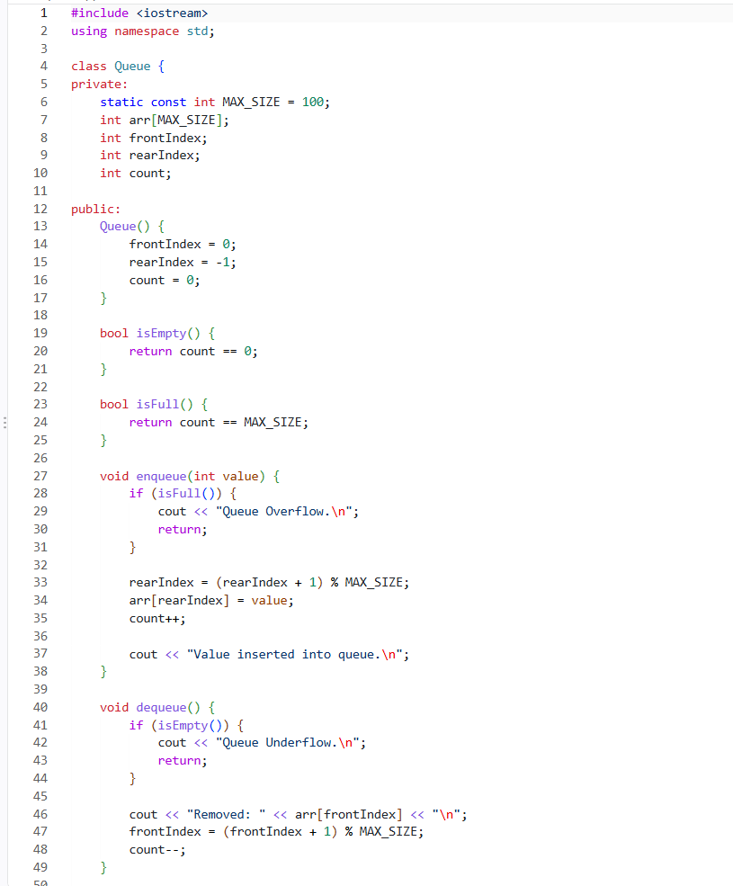
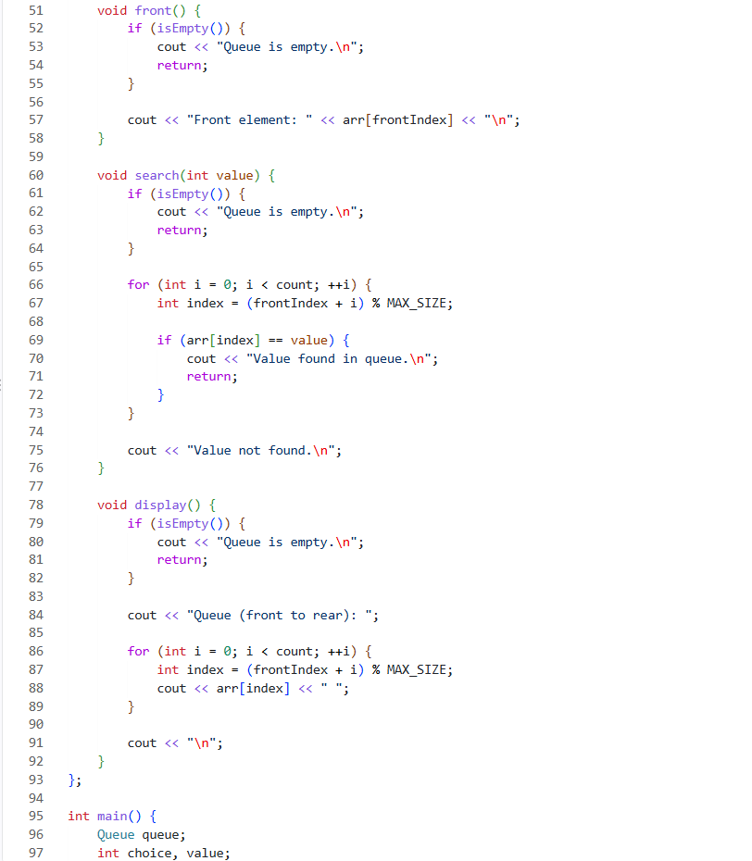
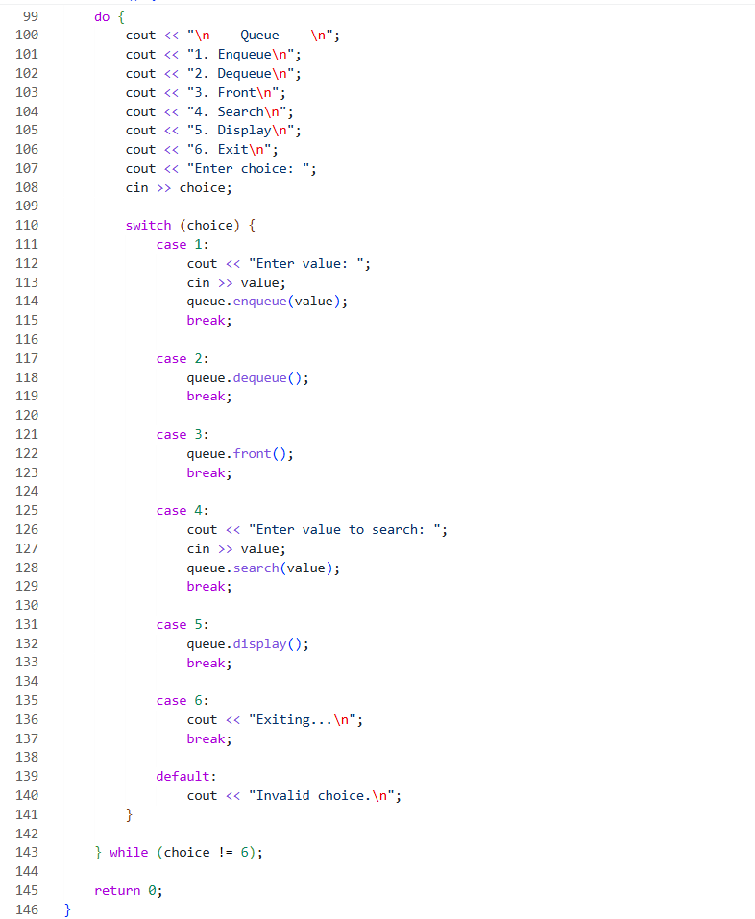
Operations and Output:-
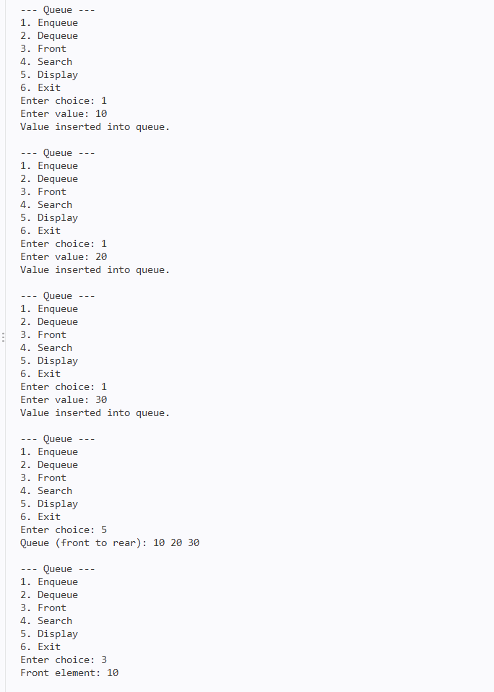
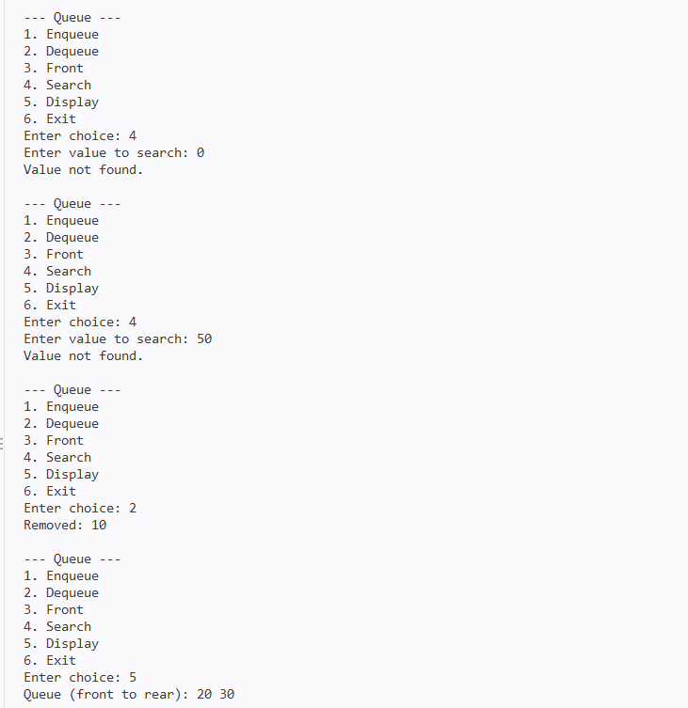
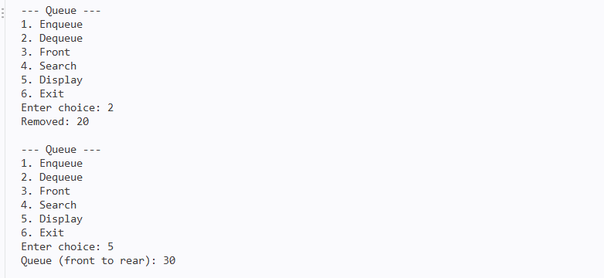

14. Result
The queue was successfully implemented using a circular array in C++.
The program correctly performs:
- Enqueue operation
- Dequeue operation
- Front element access
- Search operation
- Display operation
- Overflow detection
- Underflow detection
- Empty and full queue checks
The circular indexing mechanism allows previously occupied array positions to be reused efficiently after dequeue operations.
The implementation was successfully compiled and tested using GNU G++.

16. Conclusion
This implementation demonstrates the fundamental working of a queue using a circular array in C++. It provides practical understanding of the FIFO (First In, First Out) principle, front and rear index management, circular indexing, and queue operations.
The use of modulo arithmetic enables efficient reuse of array positions and avoids unnecessary shifting of elements. The implementation also handles overflow, underflow, empty-queue, and full-queue conditions through dedicated checks.

BINARY SEARCH TREE IMPLEMENTATION
1. Project Overview
This module implements a Binary Search Tree (BST) from scratch using C++.
A Binary Search Tree is a hierarchical data structure in which each node follows the ordering rule:
- Values smaller than a node are stored in its left subtree.
- Values greater than a node are stored in its right subtree.
The implementation uses dynamically allocated nodes and recursive functions to perform insertion, deletion, searching, and inorder traversal.
The program provides a menu-driven interface with the following operations:
- Insert
- Delete
- Search
- Display Inorder
- Exit

2. Objectives
The main objectives of this implementation are:
- Implement a Binary Search Tree using C++.
- Create tree nodes dynamically.
- Insert values according to BST ordering.
- Search for values using recursive traversal.
- Delete nodes using all three standard deletion cases.
- Perform inorder traversal.
- Find the minimum node in a subtree.
- Manage dynamically allocated memory using a destructor.

3. Technology and Environment
Parameter | Details
Language | C++
Compiler | GNU G++
Programming Concept | Classes, Objects and Recursion
Data Structure | Binary Search Tree
Memory Management | Dynamic Allocation
Traversal | Inorder
Interface | Command-Line / Menu Driven

4. Node Structure
Each tree node is represented using a Node structure.
struct Node {
int data;
Node* left;
Node* right;
};
Each node contains three components:
- data – stores the value.
- left – points to the left child.
- right – points to the right child.
The constructor initializes both child pointers to nullptr.
Node Representation
+-------+
| data |
+-------+
/ \
/ \
left right

5. BST Representation
The BST class maintains a pointer named root.
Node* root;
The root pointer stores the address of the first node in the tree.
Initially:
root → NULL
For example, inserting 50, 30, 70, 20, and 40 produces:
50
/ \
30 70
/ \
20 40
The BST property is maintained throughout the tree:
Left subtree < Node < Right subtree

6. Operations Implemented
6.1 Insert
Function
void insert(int value)
The insert() operation adds a new value while maintaining the BST ordering property.
The actual insertion is performed by the recursive helper function:
Node* insert(Node* node, int value)
Working
- If the current node is nullptr, create a new node.
- If the value is smaller than the current node, recursively insert it into the left subtree.
- If the value is greater than the current node, recursively insert it into the right subtree.
- If the value is equal to an existing node, no new node is inserted.
- Return the current node after completing the operation.
Example
Insert:
50, 30, 70, 20, 40
Result:

50
/ \
30 70
/ \
20 40
Output
Value inserted.
Complexity
Average Time: O(log n)
Worst-Case Time: O(n)
Auxiliary Space: O(h)
where h is the height of the tree.

7. Delete
Function
void remove(int value)
The remove() operation deletes a node from the BST.
The recursive helper function:
Node* remove(Node* node, int value)
handles the deletion while maintaining the BST property.
The implementation supports all three standard deletion cases.

7.1 Case 1 — Node with No Child
If the node has neither a left nor a right child, it is a leaf node.
The node is deleted directly.
Example
Before:

30
/ \
20 40
Delete 20:
30
\
40

7.2 Case 2 — Node with One Child
If the node has only one child, the node is removed and its child takes its position.
Example
Before:
30
/
20
\
25
Delete 20:
30
/
25
The implementation handles both possibilities:
- Only right child
- Only left child

7.3 Case 3 — Node with Two Children
If the node has both left and right children, the implementation uses the inorder successor.
The inorder successor is the smallest value in the node's right subtree.
The helper function:
Node* findMin(Node* node)
traverses towards the leftmost node of the subtree to find this value.
Example
Before deletion:
50
/ \
30 70
/ \
60 80
Delete 70.
The minimum value in the right subtree of 70 is 80, so 80 becomes the replacement.
Result:
50
/ \
30 80
/
60
After deletion, the BST property remains valid.
Output
The program displays:
Delete operation completed.
Note: The current implementation displays this message even if the specified value is not present in the tree.
Complexity
Average Time: O(log n)
Worst-Case Time: O(n)
Auxiliary Space: O(h)

8. Search
Function
bool search(int value)
The search operation determines whether a given value exists in the BST.
The recursive helper function:
bool search(Node* node, int value)
uses the BST ordering property to avoid unnecessary traversal.
Working
- If the current node is nullptr, the value is not present.
- If the current node contains the required value, return true.
- If the value is smaller, search the left subtree.
- If the value is greater, search the right subtree.
Output
If the value exists:
Value found.
Otherwise:
Value not found.
Complexity
Average Time: O(log n)
Worst-Case Time: O(n)
Auxiliary Space: O(h)

9. Inorder Traversal
Function
void display()
The display() function prints the elements of the tree using inorder traversal.
The recursive helper function is:
void inorder(Node* node)
The traversal follows this order:
Left → Root → Right
Example
For the tree:
50
/ \
30 70
/ \
20 40
The inorder traversal is:
20 30 40 50 70
Since the structure is a Binary Search Tree, inorder traversal produces the values in ascending order.
Output Format
Inorder traversal: 20 30 40 50 70
Complexity
Time: O(n)
Auxiliary Space: O(h)

10. Find Minimum
Function
Node* findMin(Node* node)
This helper function finds the smallest value in a subtree.
In a BST, the smallest value is located at the leftmost node.
The function repeatedly follows the left child:
while (node != nullptr && node->left != nullptr) {
node = node->left;
}
This function is specifically used during deletion of a node having two children.
Complexity
Time: O(h)
Auxiliary Space: O(1)

11. Memory Management
The BST dynamically allocates nodes using new.
To release the allocated memory, the class contains a destructor:
~BST()
The destructor calls:
clear(root);
The clear() function recursively deletes all nodes in postorder:
Left → Right → Root
This ensures that all dynamically allocated nodes are properly deallocated when the BST object is destroyed.
Complexity
Time: O(n)

12. Program Interface
The program uses a menu-driven command-line interface:
--- Binary Search Tree ---
1. Insert
2. Delete
3. Search
4. Display Inorder
5. Exit
Enter choice:
The menu continues to appear until the user selects option 5.

13. Sample Execution
The following execution demonstrates insertion, inorder traversal, search, deletion, and exit operations.
--- Binary Search Tree ---
1. Insert
2. Delete
3. Search
4. Display Inorder
5. Exit
Enter choice: 1
Enter value: 50
Value inserted.

--- Binary Search Tree ---
1. Insert
2. Delete
3. Search
4. Display Inorder
5. Exit
Enter choice: 1
Enter value: 30
Value inserted.

--- Binary Search Tree ---
1. Insert
2. Delete
3. Search
4. Display Inorder
5. Exit
Enter choice: 1
Enter value: 70
Value inserted.

--- Binary Search Tree ---
1. Insert
2. Delete
3. Search
4. Display Inorder
5. Exit
Enter choice: 1
Enter value: 20
Value inserted.

--- Binary Search Tree ---
1. Insert
2. Delete
3. Search
4. Display Inorder
5. Exit
Enter choice: 1
Enter value: 40
Value inserted.

--- Binary Search Tree ---
1. Insert
2. Delete
3. Search
4. Display Inorder
5. Exit
Enter choice: 4
Inorder traversal: 20 30 40 50 70

--- Binary Search Tree ---
1. Insert
2. Delete
3. Search
4. Display Inorder
5. Exit
Enter choice: 3
Enter value to search: 40
Value found.

--- Binary Search Tree ---
1. Insert
2. Delete
3. Search
4. Display Inorder
5. Exit
Enter choice: 2
Enter value to delete: 30
Delete operation completed.

--- Binary Search Tree ---
1. Insert
2. Delete
3. Search
4. Display Inorder
5. Exit
Enter choice: 4
Inorder traversal: 20 40 50 70

--- Binary Search Tree ---
1. Insert
2. Delete
3. Search
4. Display Inorder
5. Exit
Enter choice: 5
Exiting...

14. Complexity Analysis
Let n represent the number of nodes and h represent the height of the BST.
Operation | Average Time | Worst-Case Time | Auxiliary Space
Insert | O(log n) | O(n) | O(h)
Delete | O(log n) | O(n) | O(h)
Search | O(log n) | O(n) | O(h)
Find Minimum | O(log n) | O(n) | O(1)
Inorder Traversal | O(n) | O(n) | O(h)

Overall Space Complexity
The BST requires O(n) memory for storing n dynamically allocated nodes.
The recursive operations additionally use O(h) call-stack space, where h is the height of the tree.
For a balanced BST:
h ≈ log n
For a highly skewed BST:
h ≈ n

15. Validation and Test Cases
The implementation was tested using different operations and tree configurations.
Test Case | Operation | Expected Result
1 | Insert 50, 30, 70, 20, 40 | Values inserted successfully
2 | Display Inorder | 20 30 40 50 70
3 | Search 40 | Value found.
4 | Search unavailable value | Value not found.
5 | Delete leaf node 20 | Node removed
6 | Delete node with one child | Child replaces deleted node
7 | Delete node with two children | Inorder successor used
8 | Display after deletion | Sorted inorder traversal maintained

16. Screenshots
Program Execution:
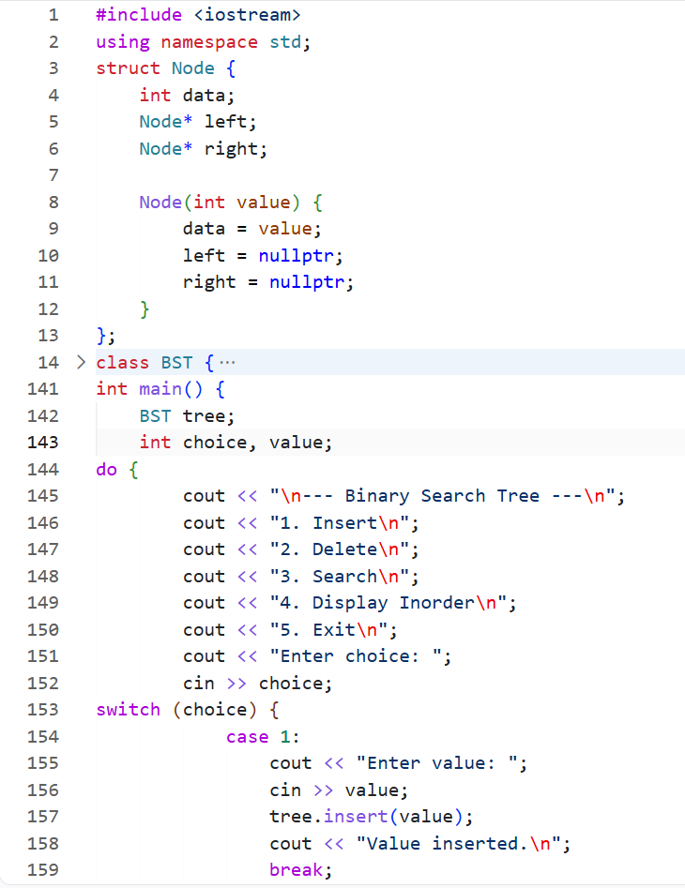
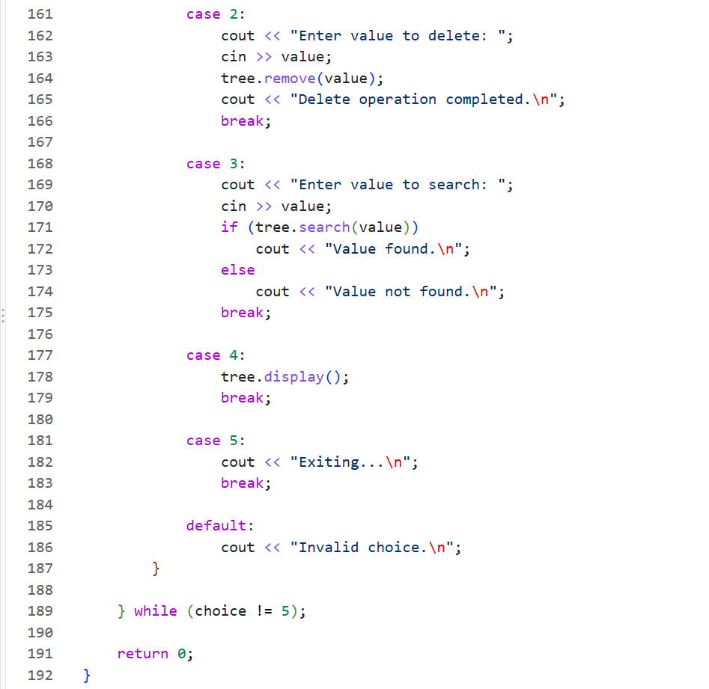

Output:
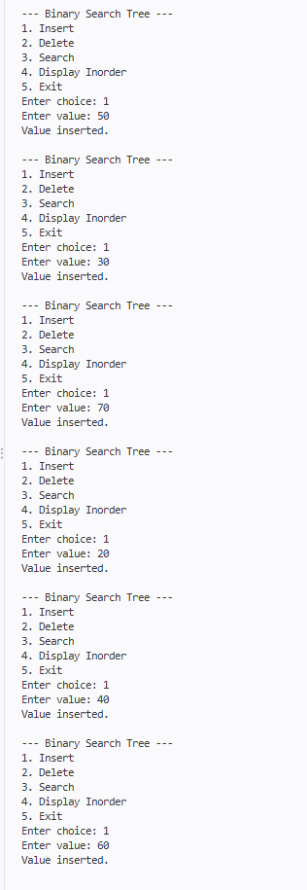
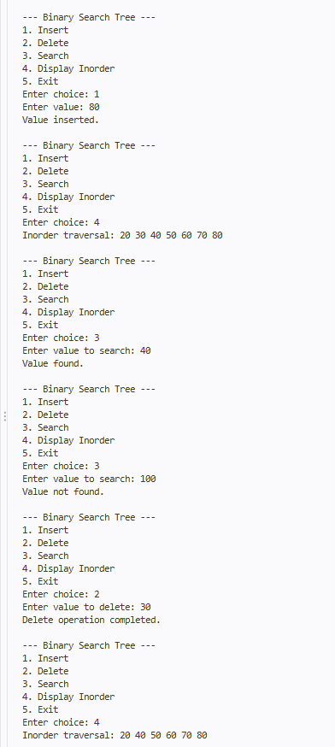

18. Result
The Binary Search Tree was successfully implemented from scratch using C++.
The program correctly supports:
- Insertion according to BST ordering
- Searching using recursive traversal
- Deletion of leaf nodes
- Deletion of nodes with one child
- Deletion of nodes with two children
- Inorder traversal
- Finding the minimum node in a subtree
- Dynamic memory deallocation
The implementation was successfully compiled and tested using GNU G++.

19. Conclusion
This implementation provides practical understanding of hierarchical data structures and the Binary Search Tree property.
The project demonstrates recursive insertion, searching, deletion, inorder traversal, and dynamic memory management. The deletion operation covers all three standard cases, including replacement using the inorder successor for nodes with two children.
The implementation also shows how the efficiency of BST operations depends on the height and structure of the tree.

